**Can Internet Regulation Prevent Fake News?**

*Whatever Author*

*7 June 2019*

**Abstract**

This is an example of a non-reproducible report full of mistakes

This report uses DSP data to investigate whether Internet regulation can prevent fake news. The DSP data contains 6000 observations from year 1980 until 2019.

The “v2smregcon” variable measures the level of legal framework protection that the country adopted to regulate the Internet. This is the distribution of this variable:

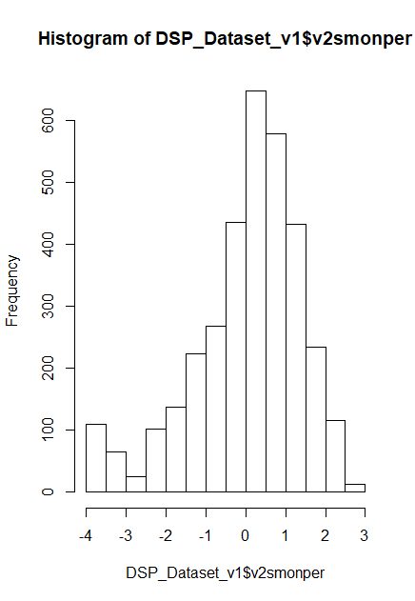

We hypothesize that better regulatory frameworks of the Internet can prevent the diffusion of fake news operated by government with the goal of propaganda. Variable “v2smgovdom” measures how often the government uses social media to disseminate false of misleading news to influence public opinion. We count 1200 non-missing values. The following histogram shows the distribution of the variable:

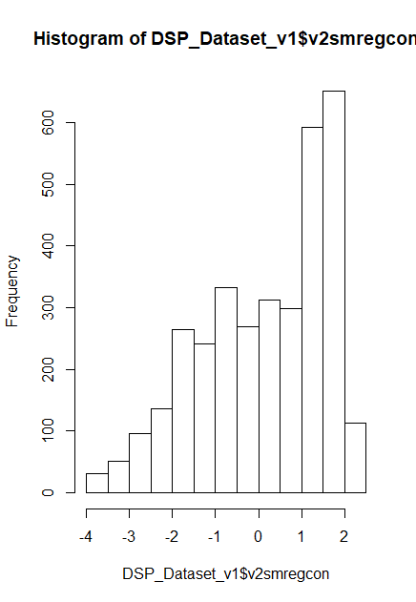

We thus estimate a linear regression model to test our hypothesis that greater regulatory framework reduces the amount of fake news. These are the results:

Call:

lm(formula = v2smgovdom ~ v2smregcon, data = DSP_Dataset_v1)

Residuals:

Min 1Q Median 3Q Max

-3.4670 -0.6030 0.0474 0.7599 2.1324

Coefficients:

Estimate Std. Error t value Pr(>|t|)

(Intercept) 0.06549 0.01645 3.981 7e-05 ***

v2smregcon 0.61527 0.01094 56.238 <2e-16 ***

---

Signif. codes: 0 ‘***’ 0.001 ‘**’ 0.01 ‘*’ 0.05 ‘.’ 0.1 ‘ ’ 1

Residual standard error: 0.9511 on 3381 degrees of freedom

Multiple R-squared: 0.4833, Adjusted R-squared: 0.4832

F-statistic: 3163 on 1 and 3381 DF, p-value: < 2.2e-16

The coefficient is 0.06 and it is negative and significant. The R-Squared is 30% which means that the model fit is good.